For #1-4, write the equation represented by each graph. (Note: A values are either 1 or -1 only)
1) 2) 3) 4)

- Complete the following for each function.
$f(x)=−|x+1|$ $f(x)=\left(\frac{1}{x+4}\right)−3$ $f(x)=2\sqrt{x−3}+6$

Domain: ________________ Domain: ________________ Domain: ________________

Range: _________________ Range: _________________ Range: _________________

- Write the quadratic function$f(x)=3x−6x+5$ in standard/vertex form. $f(x)=$____________________

- Identify all of the following for the quadratic function: $f(x)=−x^{2}−8x+\text{20}$
Vertex is a Axis of
Vertex @ ___________ MAX or MIN Symmetry @ ____________ x-int @ __________ y-int @ _________
(circle one)

- Sketch the graph of the piecewise-defined function. 9) Write the equation of the piecewise-defined function.
Be sure to label the coordinates (x, y) of all Be sure to include domains for each equation.
endpoints of the graph.

$$f\left(x\right)=\begin{aligned}\left\{\frac{1}{x}, (−∞, 0) | \right.\left\{−2x+4, [0, 4) | \right.\end{aligned}$$
- ____________

- ____________

- ____________

- ____________

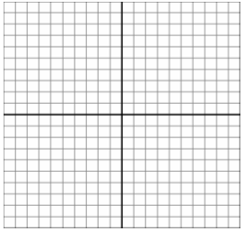

$$f\left(x\right)=\begin{aligned}\left\{ | \right.\left\{\text{____________________} | \right.\left\{ | \right.\end{aligned}$$

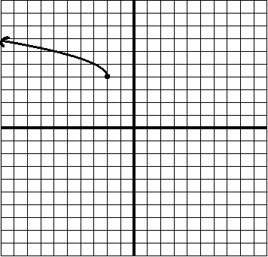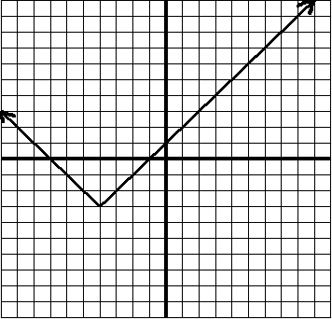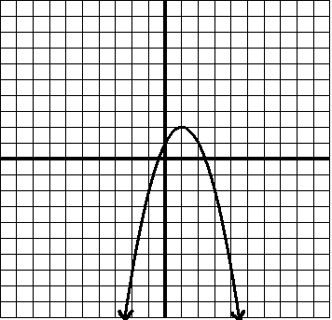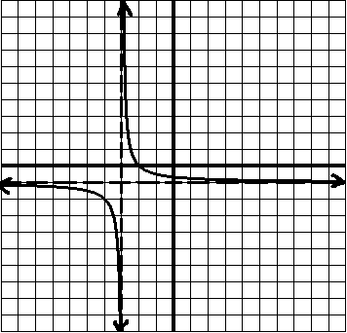

This Study Test is to be completed as preparation for the Unit Test and will be graded as a section of this test.
You are encouraged to use all available resources such as class notes, HW assignments, and the textbook.
Collaboration with classmates is not permitted and copying work is considered cheating and will result in a zero.

Vertex @ Vertex @ Vertex @

________ ________ ________

** Please show all work on separate paper and attach – no credit will be given for solutions that are missing work **

